Templates for Course Specifications

Embedded systems
University: Helwan Faculty: Faculty of Computers and Information

Course Specifications

Program(s) on which the course is given:
Major or Minor element of programs:
Department offering the program:
Department offering the course: IT

Academic year / Level:
Date of specification approval

A- Basic Information

Title: EMBEDDED SYSTEMS Code: IT

Credit Hours: 3 Lecture:3

Tutorial: Practicals:2 Total: 5

B- Professional Information

1– Overall Aims of Course

Familiarize the student with the basic concepts of embedded systems and their

applications.

2– Intended Learning Outcomes of Course (ILOs)
a) Knowledge and Understanding
Upon completing this course the student should know
a1- basic concepts of embedded systems
a2- basic organization aspects of an embedded system
a3- troubleshooting the embedded system and mastering different troubleshooting tools used.
b. Intellectual/Cognitive Skills
Upon completing this course the student should know how to
b1- analyze an embedded system and define its components
b2- discuss the disciplines used in development of an embedded system
b3- discuss and analyze a given application or case study
c. Subject-Specific Practical Skills
Upon completing this course the student will be capable of
c1- employing the knowledge acquired from the course in manipulating a simple embedded system.
General and Transferable Skills
Upon completing this course the student should know
d1- improved presentation skills

d2- improved team work skills

3- Contents
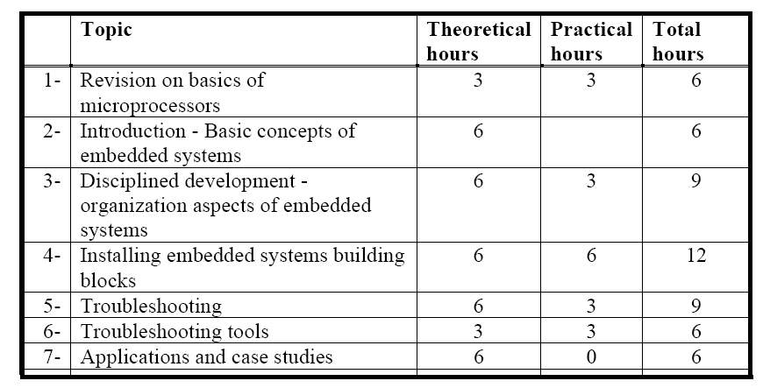

4– Teaching and Learning Methods
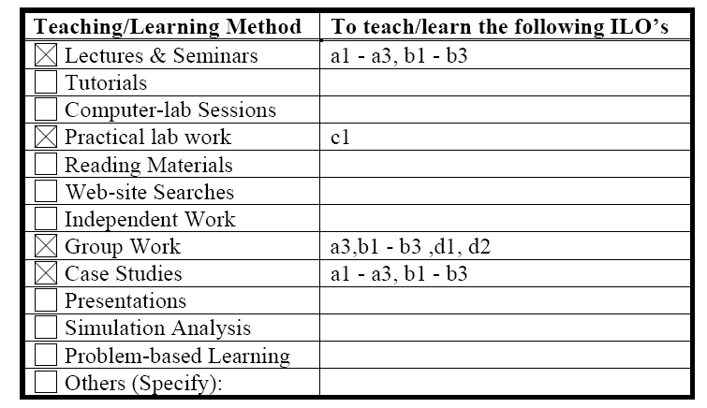

5- Student Assessment Methods
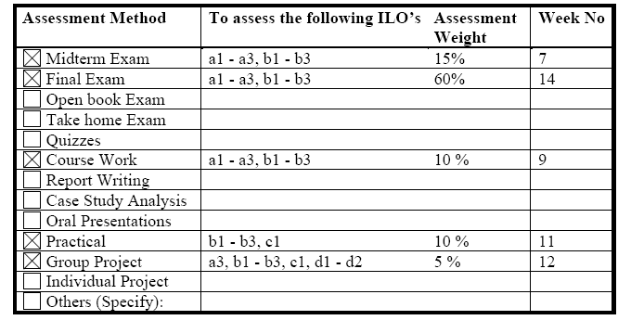

(Indicative of likely activities and tasks designed to assess how well the students achieve the ILOs. Final details will be provided to students in their first week of attendance in this course)

6- List of References
6.1- Course Notes
6.2- Essential books (text books) Embedded Systems Building Blocks, Second Edition by Jean J. Labrosse, 2002
6.3- Recommended books : Embedded Systems and Computer Architecture, First Edition by G. R. Wilson, 2002
6.4 The Art of Designing Embedded Systems by Jack G. Ganssle, 2000
6.5- Periodicals, Web sites, etc …

7- Facilities Required for Teaching and Learning
Computer & datashow, computer labs

Course Coordinator: Dr. Mahmoud Elkhouly

Head of Department:

Date: / / 2012

